**Practical-1**

**Aim: Write a C program to find the factorial of given 2 numbers using recursion.**

**Program:**

#include<stdio.h>

fact(int a)

{

if(a==1)

{

return 1;

}

else

{

return a*fact(a-1);

}

}

int b;

int factn(b)

{

if(b==1)

{

return 1;

}

else

{

return b*fact(b-1);

}

}

int main()

{

int i,j;

printf("Enter value of a\n");

scanf("%d",&i);

printf("Enter value of b\n");

scanf("%d",&j);

printf("\nFACTORIAL %d\n",fact(i));

printf("\nFACTORIAL %d\n",factn(j));

}

**Output:**

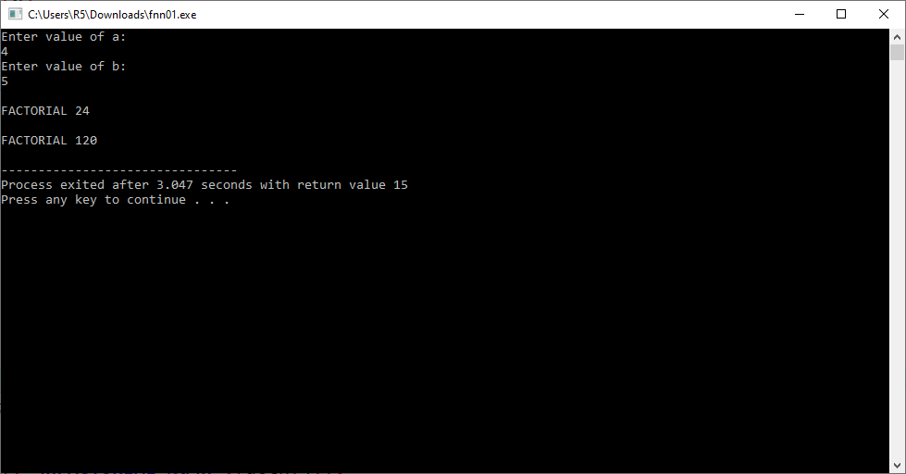

**Practical-2**

**Aim**:**Write a C program to find Sum of all Array Elements by passing array as an argument using User Define Function.**

**Program:**

#include <conio.h>

int sumofarray(int a[],int n,int i)

{

if(i<n)

return a[i]+sumofarray(a,n,++i);

return 0;

}

int main()

{

int a[1000],i,n,sum;

printf("Enter size of the array : ");

scanf("%d", &n);

printf("Enter elements in array : ");

for(i=0; i<n; i++)

{

scanf("%d", &a[i]);

}

sum=sumofarray(a,n,0);

printf("sum of array is :%d",sum);

}

**Output:**

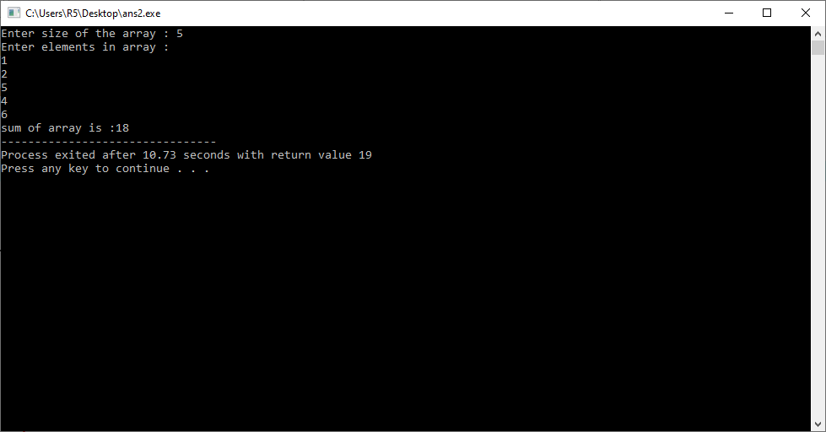

**Practical-4**

**Aim: Create a user defined function to find simple Interest, with Principal amount, no. of years, and rate as parameters.**

**Program:**

#include<stdio.h>

float interest(int P,float R, int N)

{

float SI;

SI=P*R*N/100.0;

return SI;

}

int main()

{

int p,n,i;

float r,Z;

for(i=1;i<=3;i++)

{

printf(" Enter Info for Set-%d",i);

printf("\n---------------------------------------\n");

printf("Enter Principal Amount : ");

scanf("%d",&p);

printf("Enter Interest-Rate : ");

scanf("%f",&r);

printf("Enter Time Period : ");

scanf("%d",&n);

Z=interest(p,r,n);

printf("\nSimple-Interest : %.2f\n",Z);

printf("---------------------------------------\n");

}

return 0;

}

**Output:**

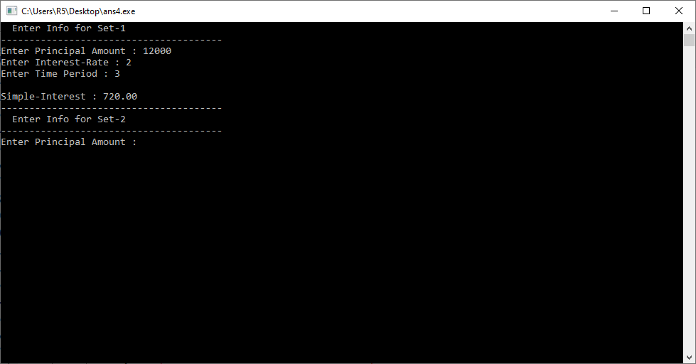

**Practical-5**

**Aim:Create user-defined nested functions that find the largest number among the given 3 numbers.**

**Program:**

#include <stdio.h>

int big(int,int,int);

int main()

{

int a,b,c;

printf("Enter the three numbers\n");

scanf("%d%d%d",&a,&b,&c);

printf("Biggest number is: %d\n",big(a,b,c));

return 0;

}

int big(int a,int b,int c)

{

if(a>b && a>c)

{

return a;

}

else

{

if(b>c)

{

return b;

}

else

{

return c;

}

}

}

**Output:**